

Step-by-Step Guide

Digital Public Dialogue on newly introduced Carbon Levy

Ministry of Climate Change & Environmental Coordination
Government of Pakistan

1. Create an Account

i. Go to https://digitaldialogue.gov.pk/login

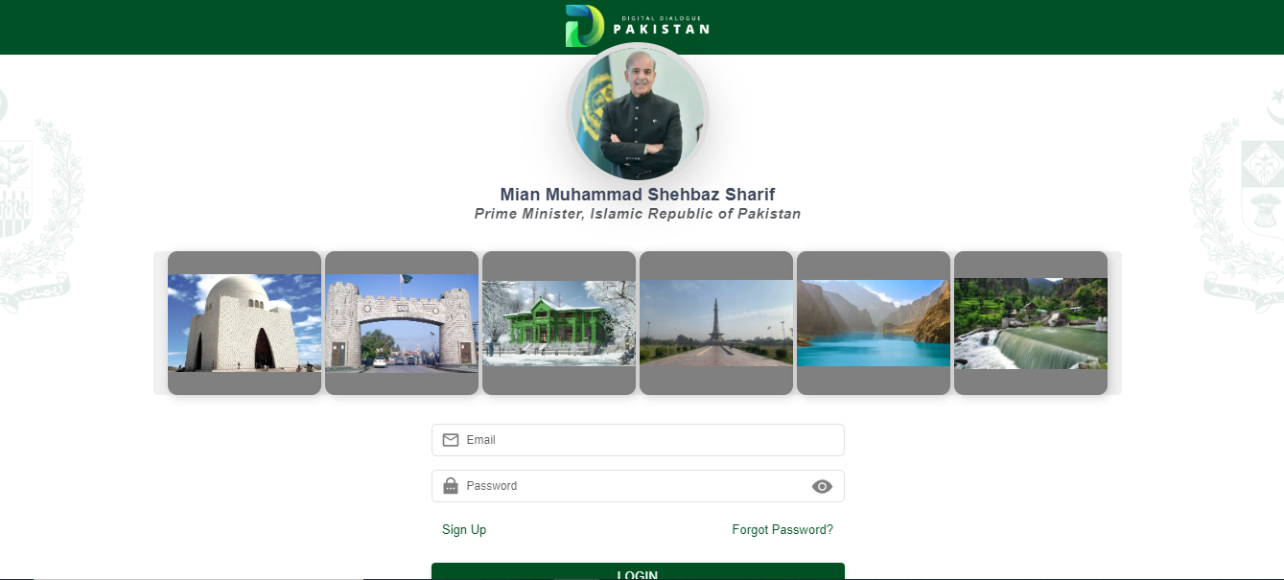

ii. Create your account
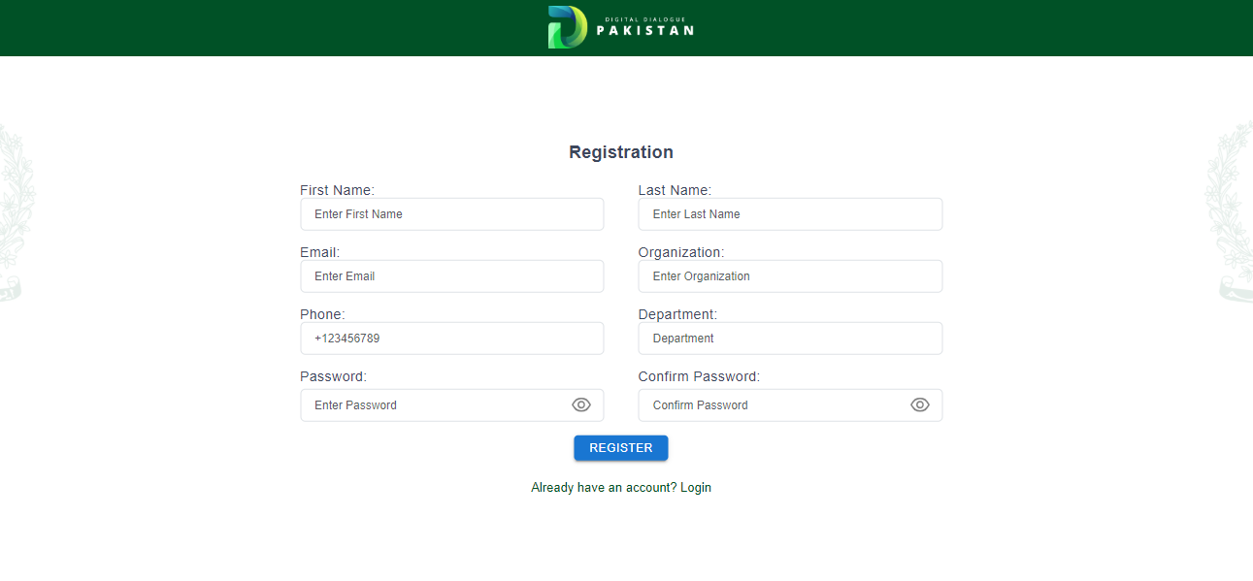

2. Log in to your Account

3. Participate in Digital Dialogue

- Enter approval code: b53b790d

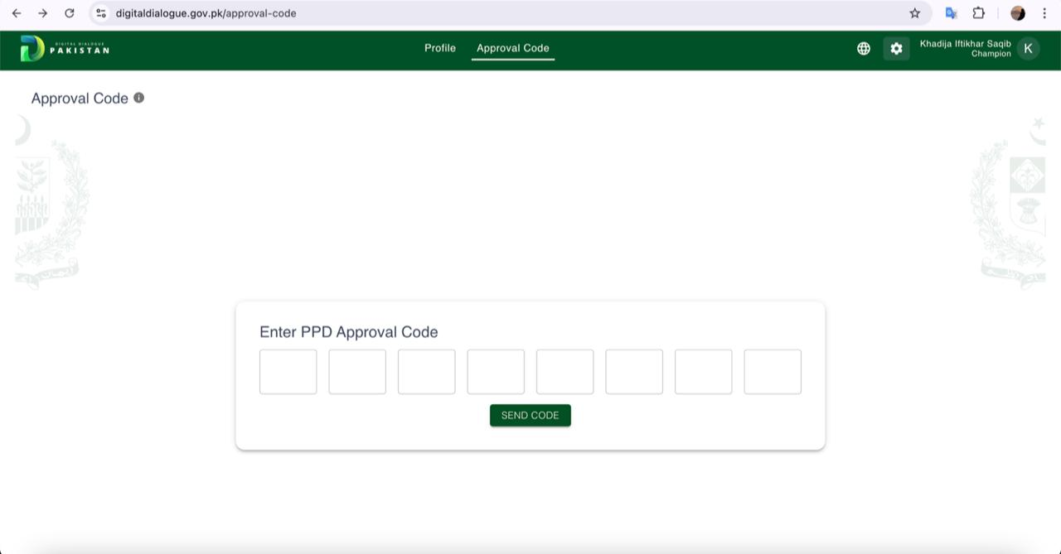

- Provide your responses to the digital dialogue

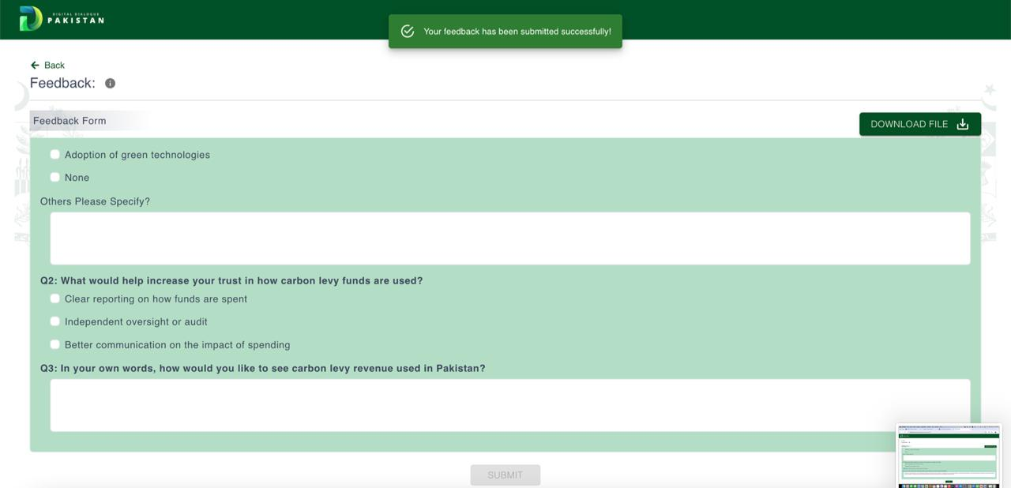

4. Submit

